ECEN 100 Project: Proximity Sensing Project

Introduction
Another of the sensors in your kit is the PIR sensor. This can sense the presence of objects or motion in the vicinity.
HC-SR501 Sensor is the sensor you’ll use for this project.
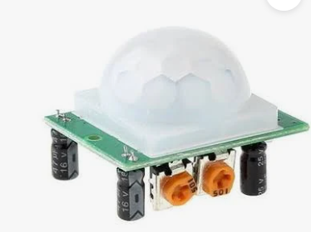

Hardware Needed
You’ll need the HC-SR501 Sensor from your kit.

Connecting to the HC-SR501 Sensor
You’ll only need three wires to connect to the PIR sensor. GND, VCC, and the signal.
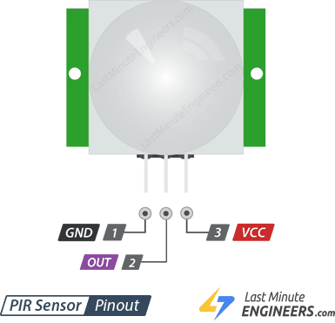
There are additional adjustments on the PIP sensor that you need to be aware of. Here is the back of the sensor.
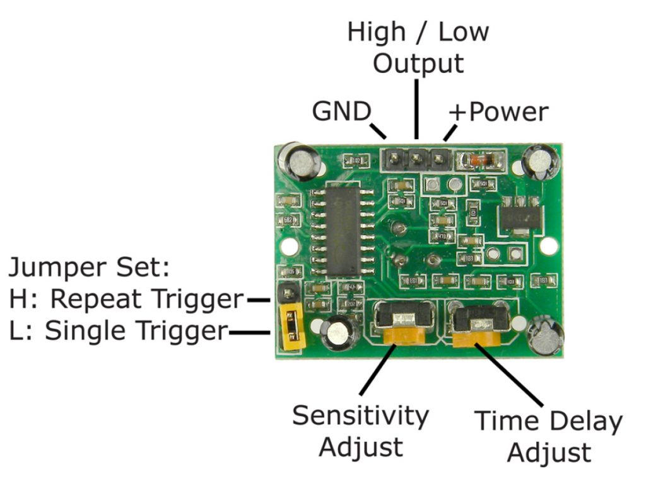

Initial Arduino Sketch to Access the HC-SR501
Here is some initial code
// Define pins
const int pirPin = 13; // PIR sensor output pin
const int ledPin = 6; // Built-in Arduino LED

void setup() {
pinMode(pirPin, INPUT); // Set PIR pin as input
pinMode(ledPin, OUTPUT); // Set LED pin as output

Serial.begin(115200);
Serial.println("Warming up sensor...");

// The HC-SR501 needs about 30-60 seconds to "settle"
// and learn the ambient infrared signature of the room.
delay(30000);
Serial.println("Sensor Active");
}

void loop() {
int motionState = digitalRead(pirPin); // Read the sensor

if (motionState == HIGH) {
digitalWrite(ledPin, HIGH); // Turn LED ON
Serial.println("Motion Detected!");
} else {
digitalWrite(ledPin, LOW); // Turn LED OFF
Serial.println("Scanning...");
}

delay(500); // Small delay to avoid flooding the serial monitor
}

When you upload and run the code you should see the led light when motion is detected. If you watch the Serial Monitor you’ll also see additional information.
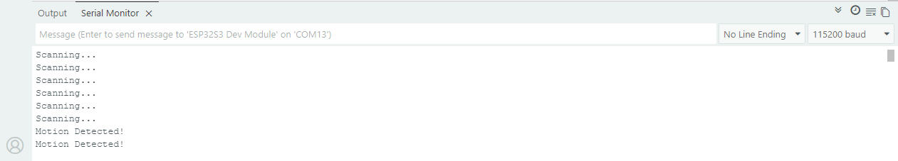
Important to note is that this sketch allows the sensor to settle 30 seconds before using it. If the sensor isn't behaving as expected, check the two orange potentiometers on the side:
- Sensitivity (SENS): Adjusts the detection distance (usually 3 to 7 meters). Turning it clockwise increases sensitivity.
- Time Delay (TIME): Adjusts how long the output stays "HIGH" after motion is detected (usually 3 seconds to 5 minutes).
- The Jumper: Most HC-SR501 modules have a yellow jumper.
  - L (Single Trigger): The sensor resets the timer after a detection; it won't trigger again until the time delay ends.
  - H (Repeatable Trigger): Every time motion is detected, the timer restarts, keeping the output HIGH as long as there is continuous movement.

Adding the Display to the Project
A single LED is fine, but you can also use the display to indicate when motion is detected. Let’s add the display to the project.
#include <Adafruit_GFX.h>
#include <Adafruit_ST7789.h>
#include <SPI.h>

// Pin definitions for ESP32-S3 (Adjust if using different pins)
#define TFT_CS 0
#define TFT_RST 1
#define TFT_DC 45
#define TFT_MOSI 3
#define TFT_SCLK 46
#define TFT_MISO 10
#define PIR_PIN 13

Adafruit_ST7789 tft = Adafruit_ST7789(TFT_CS, TFT_DC, TFT_RST);

void setup() {
// put your setup code here, to run once:
pinMode(PIR_PIN, INPUT); // Set PIR pin as input
SPI.begin(TFT_SCLK, TFT_MISO, TFT_MOSI);
// Initialize ST7789 240x320
tft.init(240, 320);
Serial.begin(115200);
tft.init(240, 320);
tft.setRotation(1); // Adjust rotation as needed
tft.fillScreen(ST77XX_BLACK);
tft.setCursor(60, 100);
tft.setTextColor(ST77XX_GREEN);
tft.setTextSize(3);
tft.println("Calibrating Sensor");
delay(30000);
tft.fillScreen(ST77XX_BLACK);

}

void loop() {
int motionState = digitalRead(PIR_PIN); // Read the sensor

tft.setCursor(60, 100);
tft.setTextColor(ST77XX_GREEN);
tft.setTextSize(3);
if (motionState) {
tft.println("Motion Detected!");
}
else
{
tft.println("No Motion Detected.");
}
delay(500);
tft.fillScreen(ST77XX_BLACK);

}

Now when the motion is sensed you’ll see the indication on the Display.

Taking the Project Further
There are several ways to take the project further:
- Add relay control to control a motor, fan, or light.
- Add the capability to a web page to indicate motion remotely.

